MINDX SERVICE AI

DAY 3 ASSIGNMENT REPORT

Submitted by
Santhoshkumar D
B.Tech Information Technology
Rajalakshmi Engineering College

Date : 07/04/2026

Objective:
To develop a modern AI-powered frontend interface and integrate it with the backend system to enable real-time chat interaction with a ticket-based workflow.

Requirements:
- Develop frontend using React.js
- Integrate frontend with backend APIs
- Implement chat UI with AI responses
- Maintain ticket-based conversation flow
- Add modern UI components (floating chat, navbar)
- Improve user experience with dynamic U

Expected Flow:
User → Open Chat → Send Message → Ticket Creation → AI Response → Display in UI
Technologies Used:
- React.js
- Java (Spring Boot)
- REST APIs
- OpenAI API
- MySQL
- Git & GitHub

Features Implemented:
1. Chat System:
- Real-time chat interface using React
- Messages dynamically rendered
- Auto-scroll to latest message
- Loading indicator ("AI is typing...")
2. Ticket-Based System
- First message creates a ticket automatically
- Ticket ID is stored in frontend
- All future messages use same ticket
- Maintains full conversation history
3. AI Integration
- Connected to OpenAI API
- Context-aware responses using history
- Fallback responses for errors
4. Modern UI (Key Highlight)
- Floating chat button (bottom-right)
- Smooth opening animation
- Gradient-based modern design
- Navbar with MindX branding
5. Multi-Screen Chat UI
- Home Screen (MindX Assistance)
- Chat with AI Screen
- Contact Support Screen

6. Smart UI Features
- Quick reply suggestions
- Dynamic UI switching
- Clean SaaS-style layout
System Flow:
- User clicks chat icon
- Chat window opens
- User selects "Chat with AI"
- First message → Ticket created
- AI generates response
- Messages displayed in UI
- Conversation continues using Ticket ID

UI Flow:
Home → Chat with AI → Conversation → Contact Support

Screenshots:
Figure 1: Floating chat button
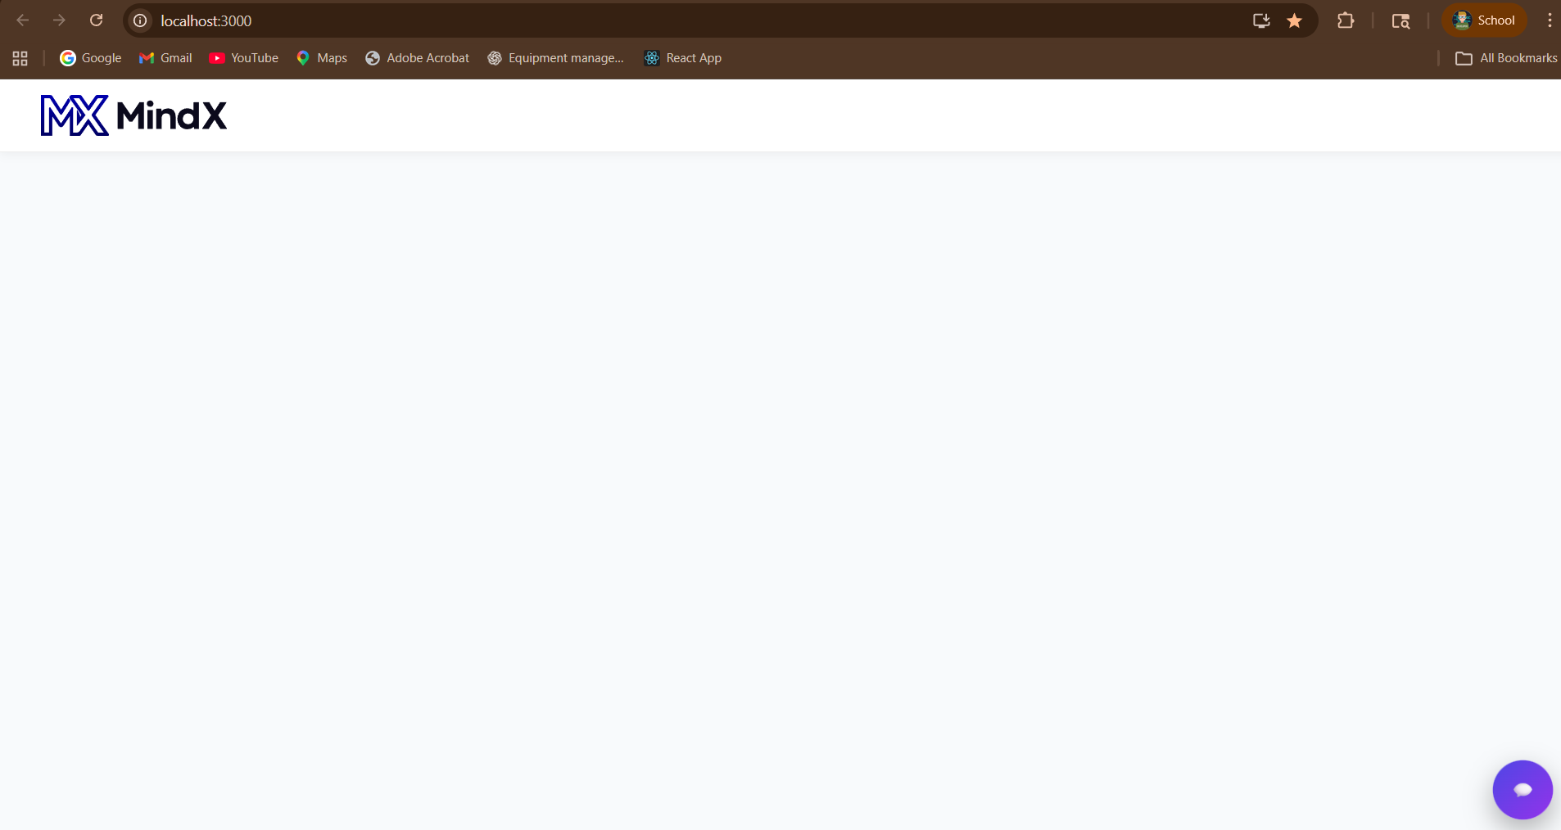
Figure 2: Home screen (MindX Assistance)
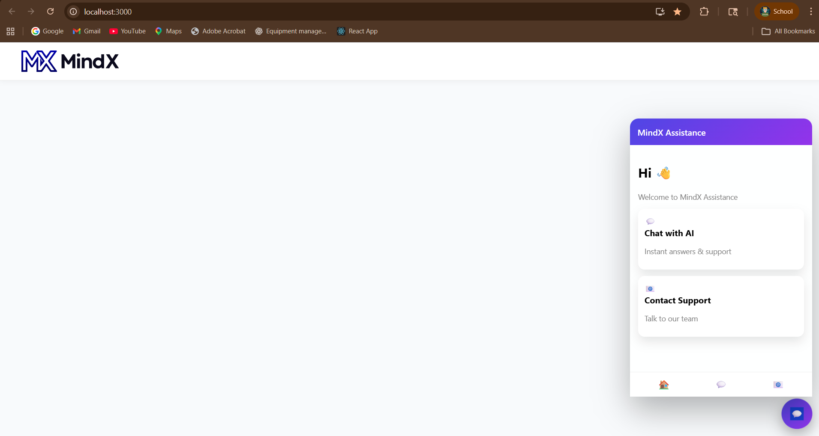
Figure 3: Chat UI (AI conversation)
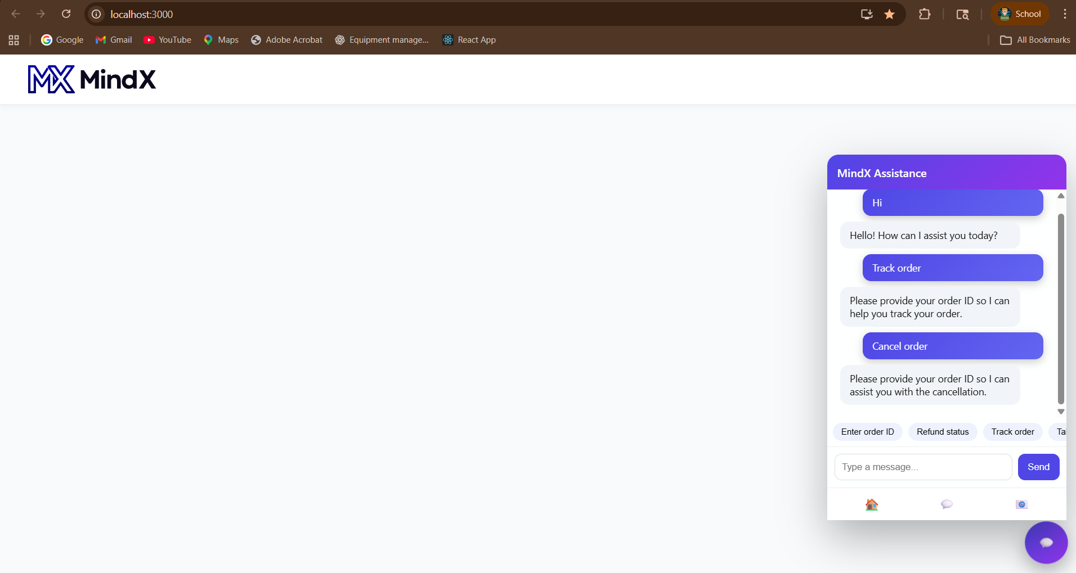
Figure 4: Contact Support screen
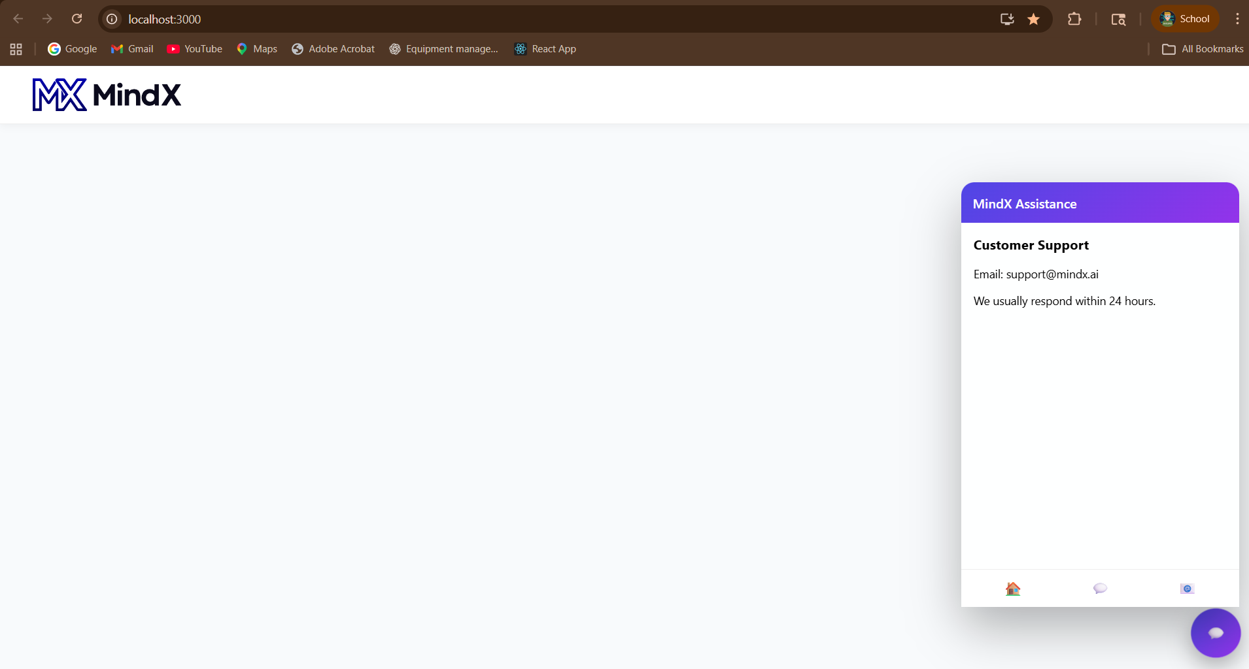

Database:
The data is stored in MySQL database with two tables:
- Ticket table
- Message table
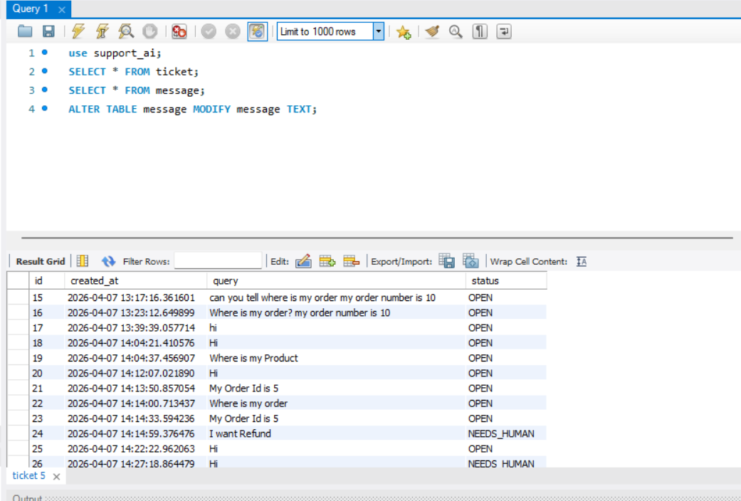
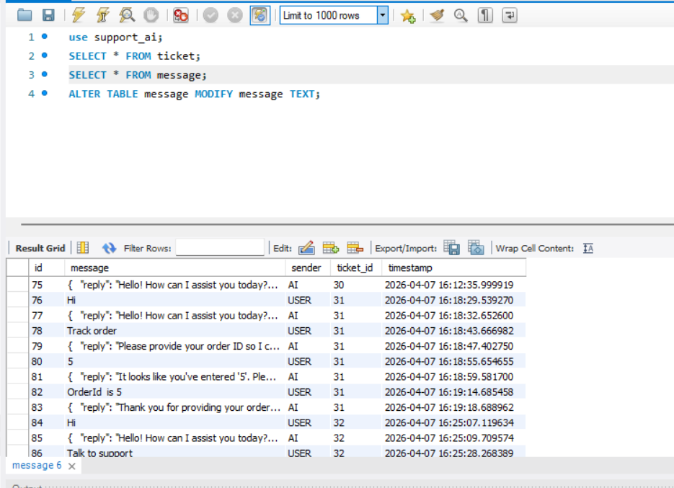

Challenges faced:
- Fixing frontend build issues
- Handling API integration errors
- Managing ticket ID across requests
- Fixing OpenAI role error
- Designing responsive UI
Solution:
- Corrected API request handling
- Implemented proper state management
- Fixed role mapping (assistant instead of ai)
- Improved error handling
- Structured UI components properly
Conclusion:
Successfully implemented an AI-based response system and escalation logic. The system now behaves like a real-world support platform with intelligent response handling and ticket prioritization. This implementation demonstrates backend system design, AI integration, and real-time decision-making logic.

GitHub Repository:
https://github.com/SANTHOSHDEV22/mindx-support-ai

